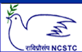
National Council for Science and Technology Communication (NCSTC),
Department of Science and Technology (DST), Govt. of India, New Delhi.
Training Program (Workshop) on
Science Communication through Digital Media
(10th to 14th June 2011)
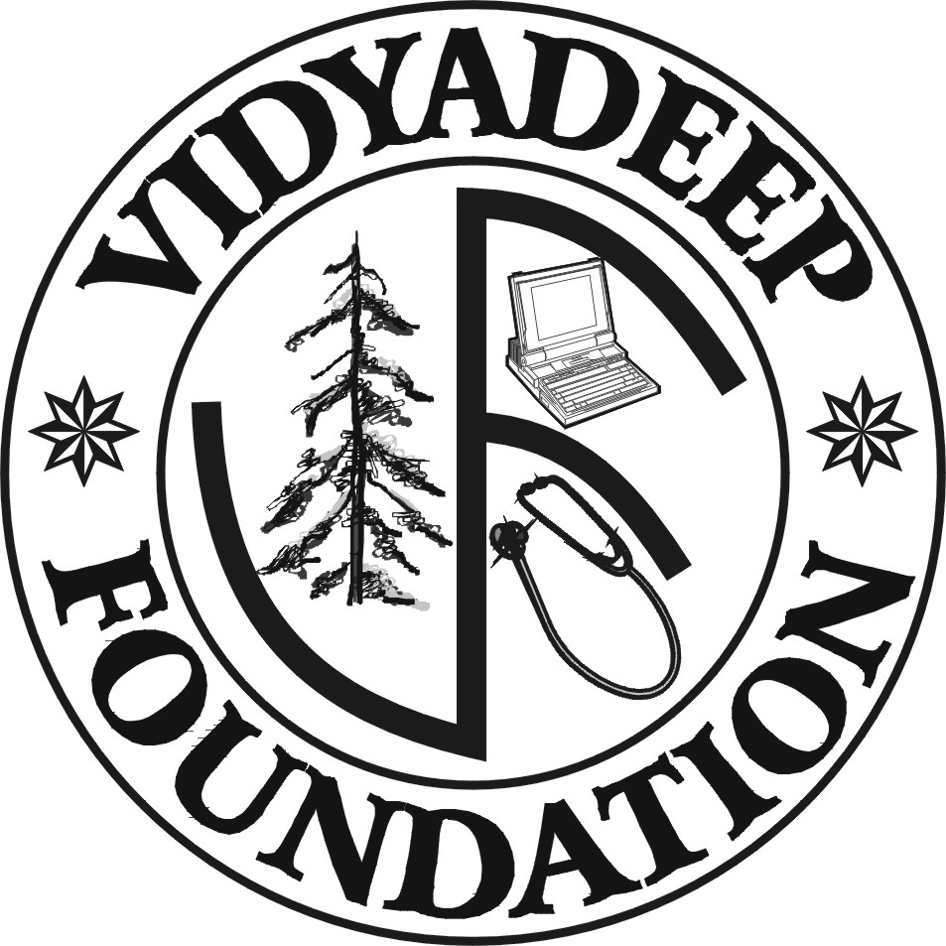 | Organised by  VidyaDeep Foundation, Satara  &  Sakal Social Foundation | 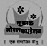

Program Venue: Gogate Joglekar College, Ratnagiri

Registration Form

1. Name of the Delegate:

2. Postal Address:

3. Contacts
Phone:
Fax:
Mobile:
E-mail/ Website:

4. Details regarding contribution in the field of Science Communication:

5. Travel Details: from: To:

Travel Support: Required/ Not Required

6. Accommodation: Required/ Not Required

7. Area of the Interest: Audio recording/ Script writing/ Animation design/
Video recording and editing / Web page design/ Any other

8. Area of Expertise: Anchor / Journalist/ Science Communicator/ Animator/ Audio Analyst/ Editor/ any other

Date: Signature

Send Registration Forms to:
Mr. Mangesh More,Daily Sakal 9011918282
Mr. Kedar Lingayat, Daily Sakal 9960035874
Address: Sakal Vibhagiy Karyalay,Shirke Plaza, First Floor,
Opp. To Collector Office, Ratnagiri.
Phone No:02352-220543,223604

