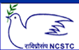
National Council for Science and Technology Communication (NCSTC),
Department of Science and Technology (DST), Govt. of India, New Delhi.
Training Program (Workshop) on
Science Communication through Digital Media
(22nd to 26th April 2011)
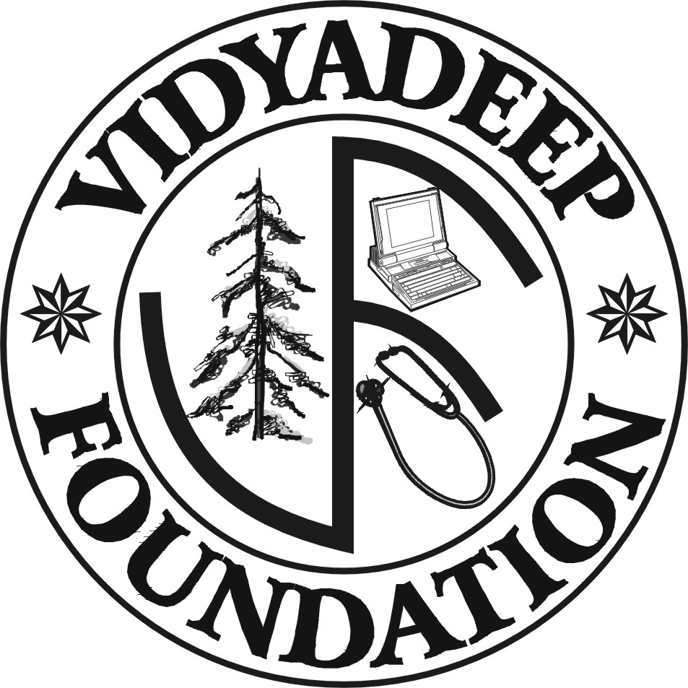 | Organised by  VidyaDeep Foundation, Satara  &  Sakal Social Foundation | 

Program Venue: Centre for Studies in Rural Development-Institute of Social Work & Research, CSRD-ISWR), Station Road, Ahmednagar

Registration Form

1. Name of the Delegate:

2. Postal Address:

3. Contacts
Phone:
Fax:
Mobile:
E-mail/ Website:

4. Details regarding contribution in the field of Science Communication:

5. Travel Details: from: To:

Travel Support: Required/ Not Required

6. Accommodation: Required/ Not Required

7. Area of the Interest: Audio recording/ Script writing/ Animation design/
Video recording and editing / Web page design/ Any other

8. Area of Expertise: Anchor / Journalist/ Science Communicator/ Animator/ Audio Analyst/ Editor/ any other

Date: Signature

Send Registration Forms to:
Mr. Makarand Bidwai (Sr. Executive, Circulation, Sakal) Cell: 9881098291
Mr. Sachin Tawale (Jr. Executive, Pagination, Sakal) Cell: 8888866436
Daily Sakal,
Patrakar Vasahat, Savedi road, Ahmednagar

