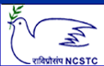
National Council for Science and Technology Communication (NCSTC),
Department of Science and Technology (DST), Govt. of India, New Delhi.
Training Program (Workshop) on
Science Communication through Digital Media
(21st to 27th June 2009)
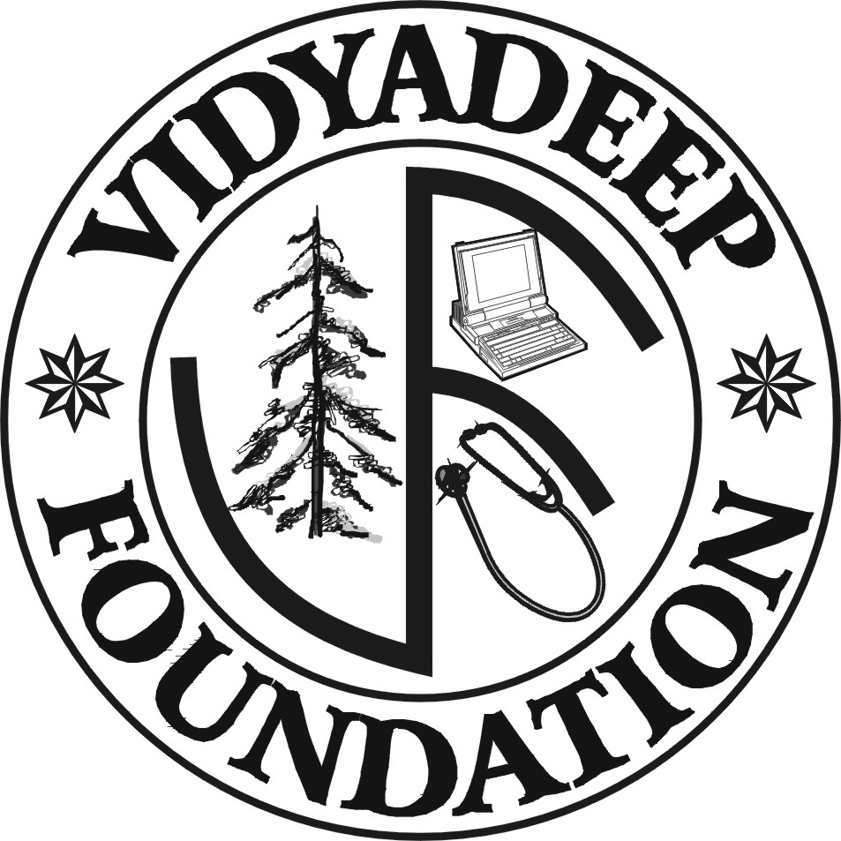 | Organised by  VidyaDeep Foundation, Satara  &  H.P.T Arts & R.Y.K. Science College and Science Forum, Nashik-422005.

Registration Form

1. Name of the Delegate:

2. Postal Address:

3. Contacts
Phone:
Fax:
Mobile:
E-mail/ Website:

4. Details regarding contribution in the field of Science Communication:

5. Travel Details: from: To:

Travel Support: Required/ Not Required

6. Accommodation: Required/ Not Required

7. Area of the Interest: Audio recording/ Script writing/ Animation design/
Video recording and editing / Web page design/ Any other

8. Area of Expertise: Anchor / Journalist/ Science Communicator/ Animator/ Audio Analyst/ Editor/ any other

Date: Signature

Send Registration Forms to:
Prof. Pravin Joshi. Local Coordinator
Lecturer, Physics Department,
H.P.T Arts & R.Y.K. Science College, and Science Forum, Nashik-422005
E-mail: skycom_nsk@rediffmail.com
Phone: 0253-2398887 , Cell: 9423968110

