Rashtriya Vigyan Evam Prodyogiki Sanchar Parishad (NCSTC)
DST, Govt. of India, New Delhi.
Training Programme (Workshop)
Science Communication through Digital Media
22nd to 26th April 2011
Organized by
VidyaDeep Foundation and Sakal Social Foundation

21th century is the world of digital science. Internet/ Websites and T.V. Channels are totally ruling the world. Any news can be passed on to anywhere across the globe within seconds and the whole society will react to that. In this scenario, there is a huge demand for science writers who can communicate through digital media to meet the requirements of this modern era. Availability of softwares for film editing and other post production process and the possibility of filmless recording using digital cameras, make handling of audio-video, visual media quiet handy for those with creative spirit. Equipping the young graduates and journalists with effective skills of science reporting and communicating through digital media has become highly necessary.
With this background, VidyaDeep Foundation has conducted six workshops on Science Communication through Digital / Visual Media.

Objectives of the Workshop:
To train young journalists and science graduates with the skills of science communication in the Audio- Visual and Digital Media. (Like TV, E-Journalism and Web portal) and to encourage them to take up career in this area.
1. To identify the young science communicators in digital media and to give them in depth training in popular science communication.
2. To arrange debates and discussions with experts in the field of digital and visual science communication, for the benefit of the science communicators in visual media.
3. Preparing the scripts for science communication through visual/digital media.
4. Training young journalists in developing the video documentaries based on science information and enhancing their presenting skills.
5. Encouraging scientists to prepare some scripts and programmes for general public and present through the visual/digital media.
6. To encourage editors of print and electronic media to provide more space/time for science communication and provide a platform for presentation of this idea.
7. To design animated movies on “History of Scientific Innovations”.
8. To create multimedia contents on science and technology communication.

Duration & Dates
5 days (Five) 22nd (Friday) to 26th (Tuesday) April, 2011

Registration
No registration fee. Food and accommodation will be provided by organization on complementary basis.

Participants
1. Science Graduates
2. Scientists & Journalists/ Journalism students with science background
3. Web and Portal designers
4. Professionals & Media Personnel

About NCSTC
The National Council for Science and Technology Communication (NCSTC) was constituted in 1982 by the Ministry of State for Science & Technology, Govt. of India for popularization of science communication. NCSTC has played a pioneering role and blazed new trails on the Indian science popularization scene. The major emphasis of NCSTC has been on development, adaptation, promotion and use of different communication methodologies. Various media, traditional and non-traditional, being utilized for the purpose include print, audio/radio, video/TV and folk-forms like songs, dances, street-plays, puppetry, etc. NCSTC is the organization that has taken a whole lot of steps and actions to prepare science communicators of different kinds at different levels, for different purposes in almost all States. The ultimate objective is that every State/UT of India would have enough good quality science communicators to undertake and carry out a wide variety of science popularization activities and programmes in the entire state, including training of more resource persons.

Medium of Instruction: English/Marathi/Hindi

Schedule of the Training Programme (Workshop)
1st Day Welcome & Inauguration
2nd Day Methods of Science and Technological Communication
3rd Day Use of Sofwares for Science Communication through Digital Media.
4th Day Interactive Script Writing and Use of Audio and Video.
5th Day Use of Animations & Project Design on “Historical Development of Scientific Innovations.

Selection of Participants
The participants will be selected from all over Maharashtra State and preference will be given to those who are in the beginning of their career as popular science communicators.
Organising Committee

Mentor & Principal Coordinator
Dr. Manoj Patatiriya
Scientist “F”, NCSTC, Govt. of India, New Delhi

Coordinators
Dr. Suresh Pathare,
Director, CSRD-ISWR, Ahmednagar
Prof. Dipak Tatpuje
Founder – Secretary, VidyaDeep Foundation, Satara
&
Mr. Abhijit Patil,
Manager, Sakal Social Foundation
Local Organising Committee-
Mr. Bhaga Warkhade (Chief Reporter, Sakal)
Mr. Hanumant Bankar (Manager,Circulation,Sakal)
Mr. Makarand Patil (Asst. Manager,Advt,Sakal)
Mr. Suresh Mugutmal, Technical Coordinator, CSRD-ISWR
Mr. A.P Sontale, Administrative Coordinator, CSRD-ISWR
: Registration Form Available / Submission :
Mr. Makarand Bidwai (Sr. Executive, Circulation, Sakal) Cell: 9881098291
Mr. Sachin Tawale (Jr. Executive, Pagination, Sakal) Cell: 8888866436
Daily Sakal,
Patrakar Vasahat, Savedi road,
Ahmednagar

Visit us at:
www.vidyadeep.org
www.sctdm.com

Program Venue:
Centre for Studies in Rural Development-Institute of Social Work & Research,
(CSRD-ISWR)
Station Road, Ahmednagar

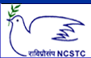
National Council for Science and Technology Communication (NCSTC),
Department of Science and Technology (DST), Govt. of India, New Delhi.
Training Program (Workshop) on
Science Communication through Digital Media
(22nd to 26th April 2011)
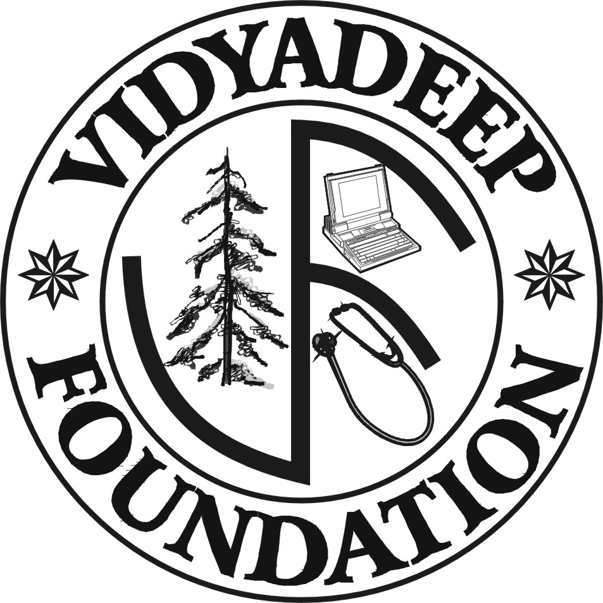 | Organised by  VidyaDeep Foundation, Satara  &  Sakal Social Foundation | 

Program Venue: Centre for Studies in Rural Development-Institute of Social Work & Research, CSRD-ISWR), Station Road, Ahmednagar

Registration Form

1. Name of the Delegate:

2. Postal Address:

3. Contacts
Phone:
Fax:
Mobile:
E-mail/ Website:

4. Details regarding contribution in the field of Science Communication:

5. Travel Details: from: To:

Travel Support: Required/ Not Required

6. Accommodation: Required/ Not Required

7. Area of the Interest: Audio recording/ Script writing/ Animation design/
Video recording and editing / Web page design/ Any other

8. Area of Expertise: Anchor / Journalist/ Science Communicator/ Animator/ Audio Analyst/ Editor/ any other

Date: Signature

Send Registration Forms to:
Mr. Makarand Bidwai (Sr. Executive, Circulation, Sakal) Cell: 9881098291
Mr. Sachin Tawale (Jr. Executive, Pagination, Sakal) Cell: 8888866436
Daily Sakal,
Patrakar Vasahat, Savedi road, Ahmednagar

