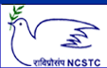
National Council for Science and Technology Communication (NCSTC),
Department of Science and Technology (DST), Govt. of India, New Delhi.
Training Program (Workshop) on
Science Communication through Digital Media
(25th to 29th Dec. 2010)
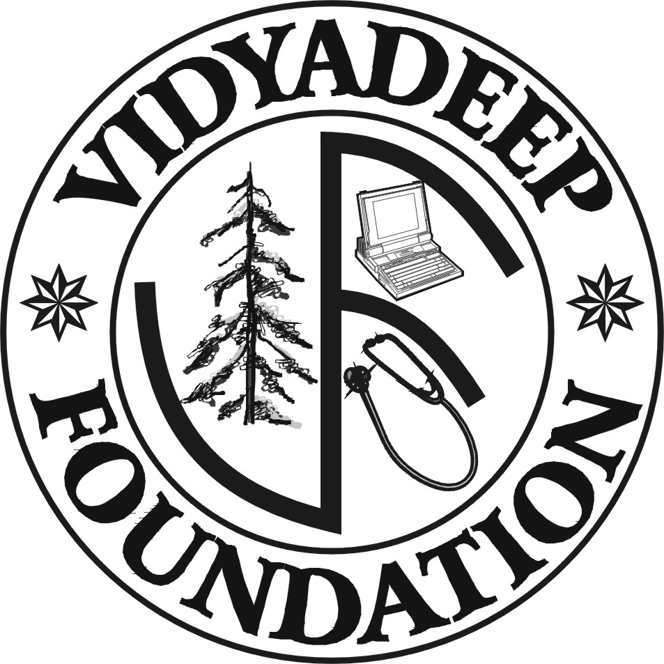 | Organised by  VidyaDeep Foundation, Satara  &  Suraj Foundation, Kupwad (Sangli)

Registration Form

1. Name of the Delegate:

2. Postal Address:

3. Contacts
Phone:
Fax:
Mobile:
E-mail/ Website:

4. Details regarding contribution in the field of Science Communication:

5. Travel Details: from: To:

Travel Support: Required/ Not Required

6. Accommodation: Required/ Not Required

7. Area of the Interest: Audio recording/ Script writing/ Animation design/
Video recording and editing / Web page design/ Any other

8. Area of Expertise: Anchor / Journalist/ Science Communicator/ Animator/ Audio Analyst/ Editor/ any other

Date: Signature

Send Registration Forms to:
Suraj Foundation
Krishna Valley Complex,
Pt No P-16,MIDC,Kupwad
Tal:Miraj Dist:Sangli
Phone: 0233-2644005 Cell: 9326778143, 9970055688

